ASSIGNMENT 1
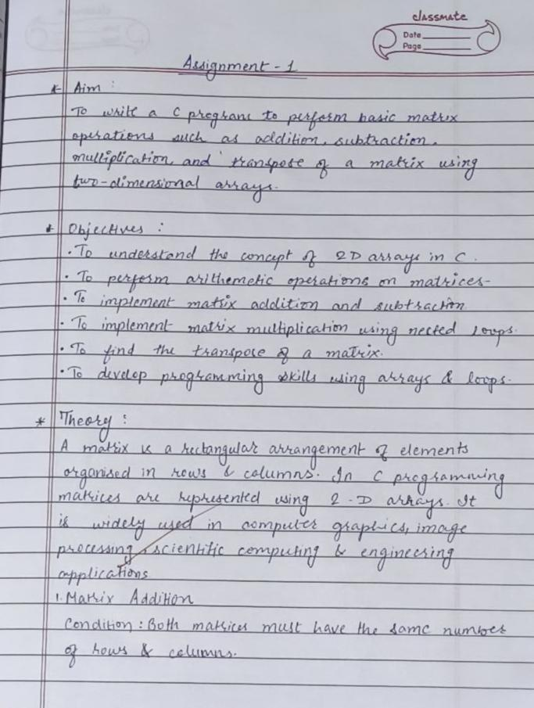
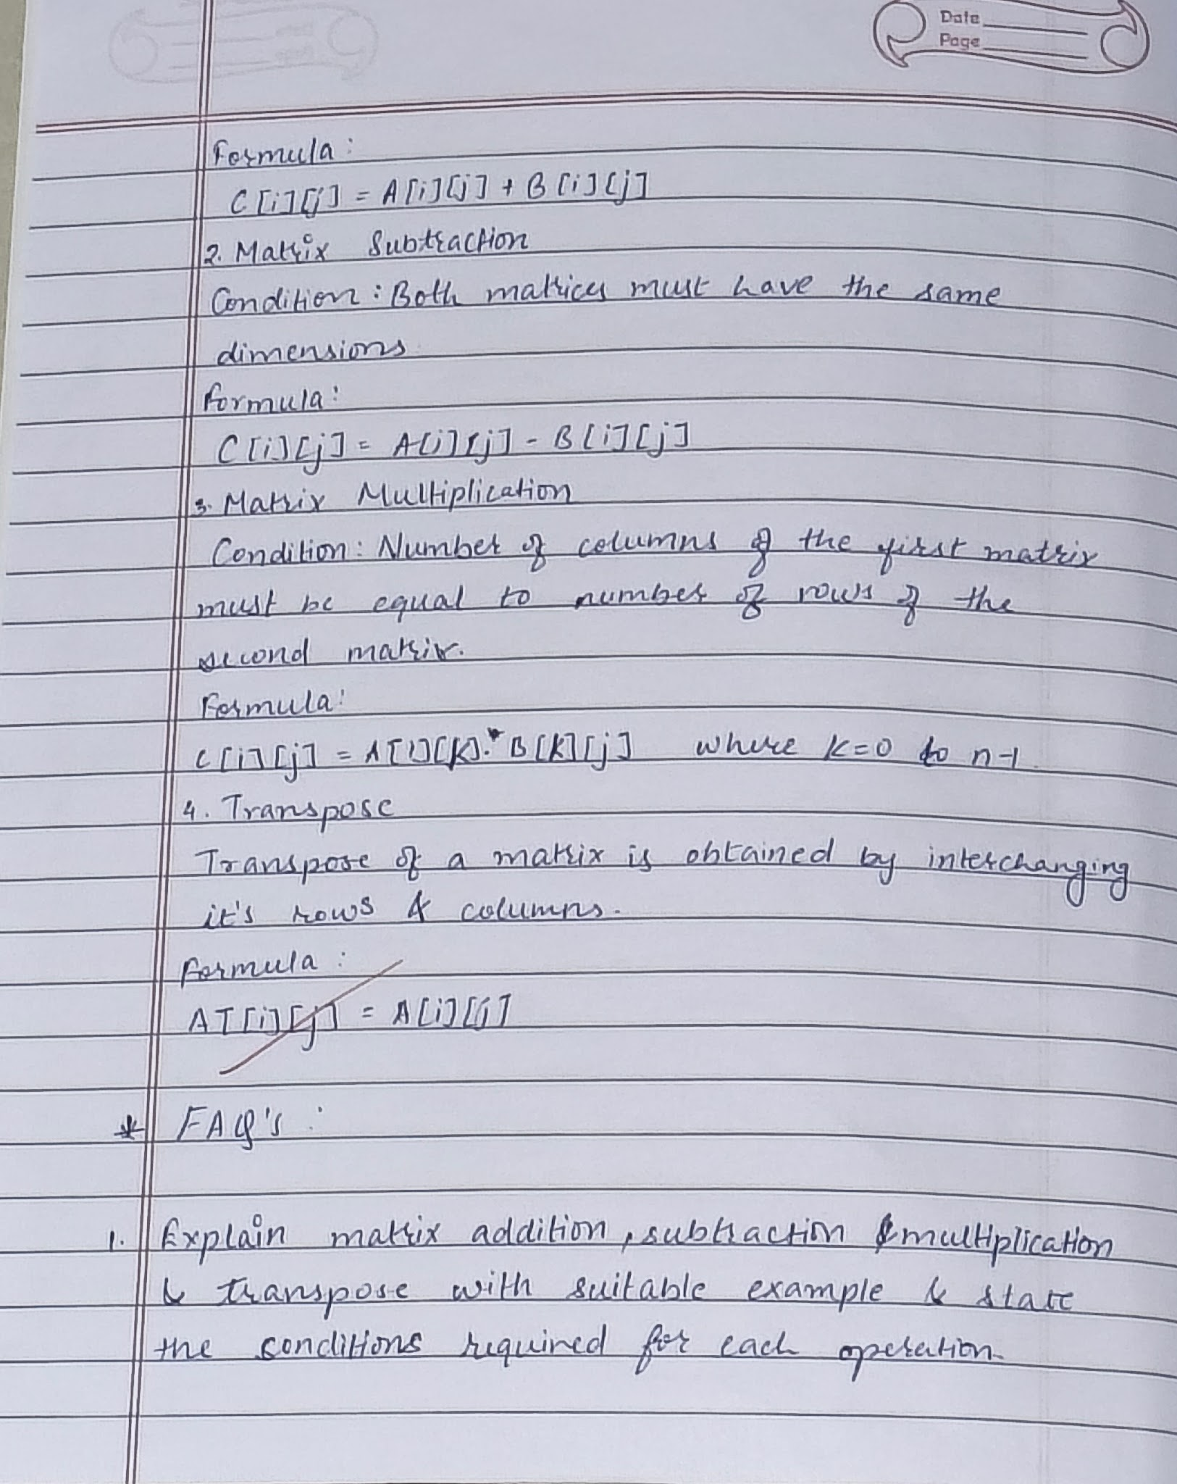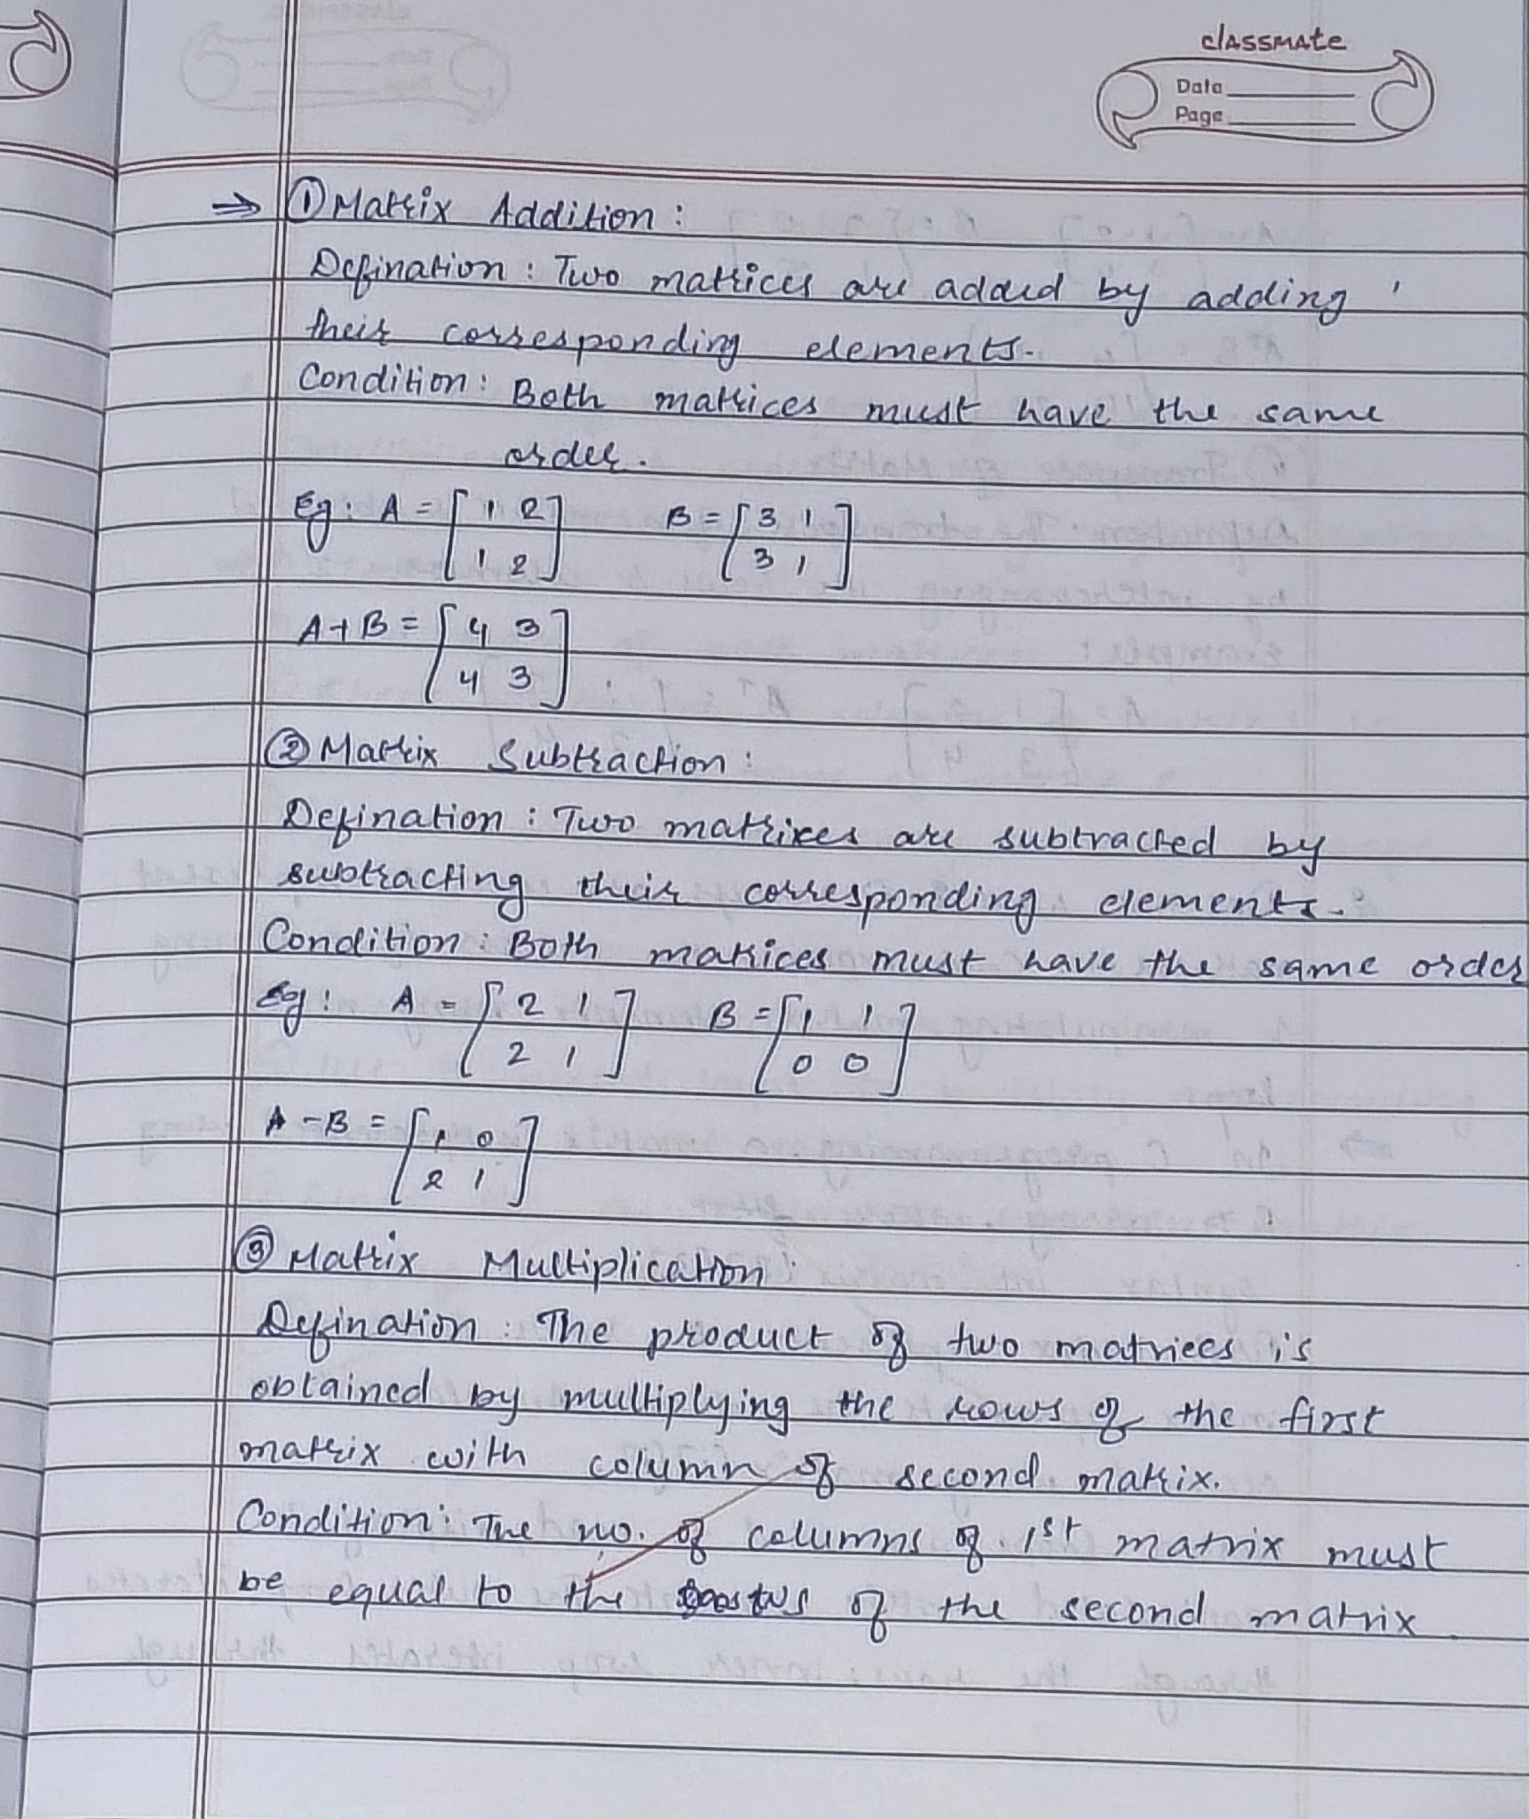
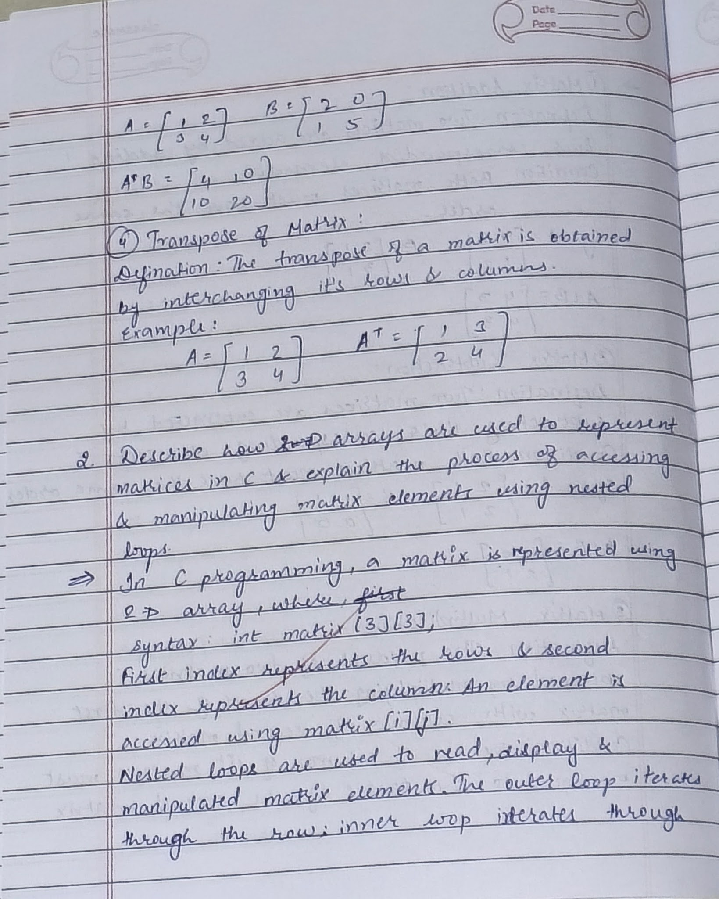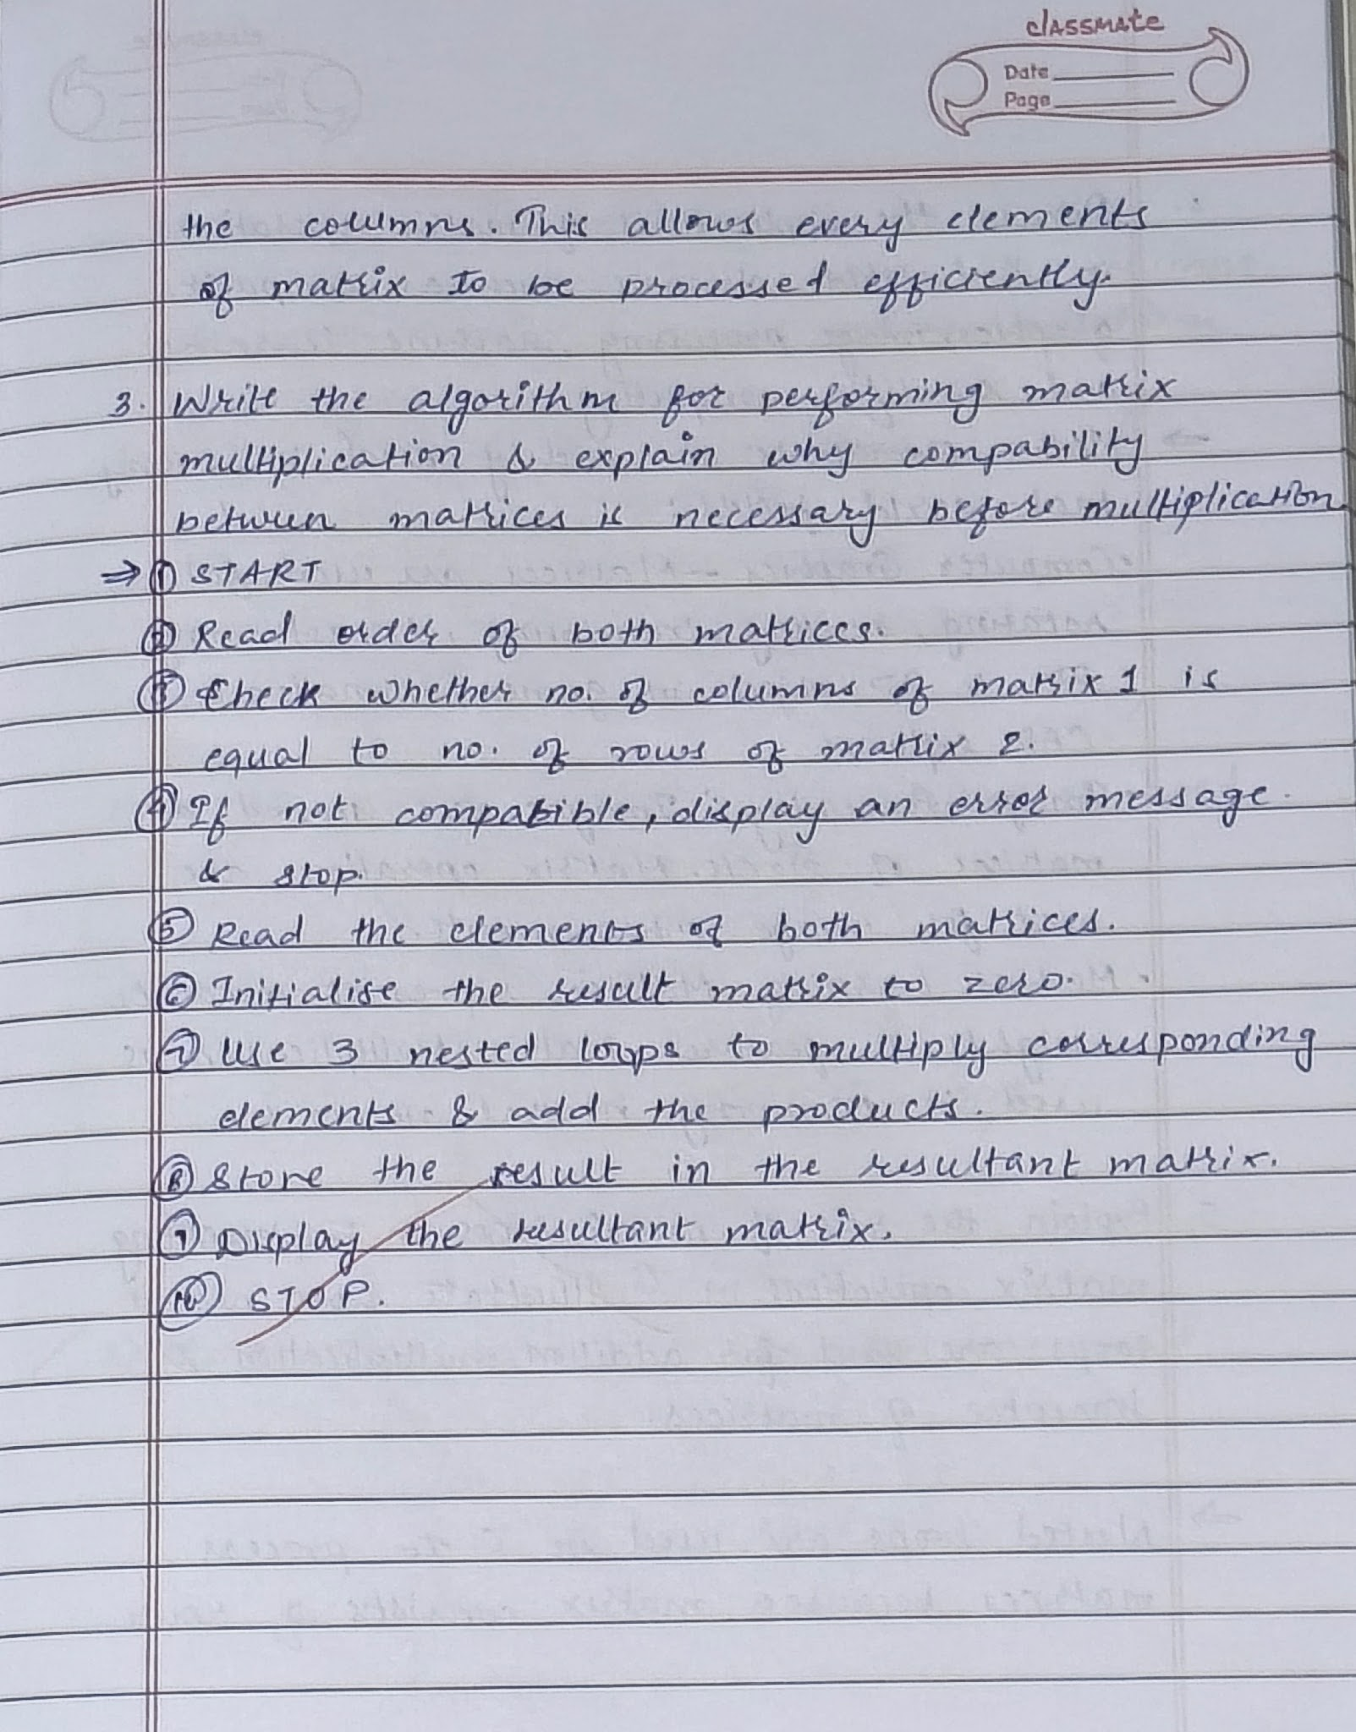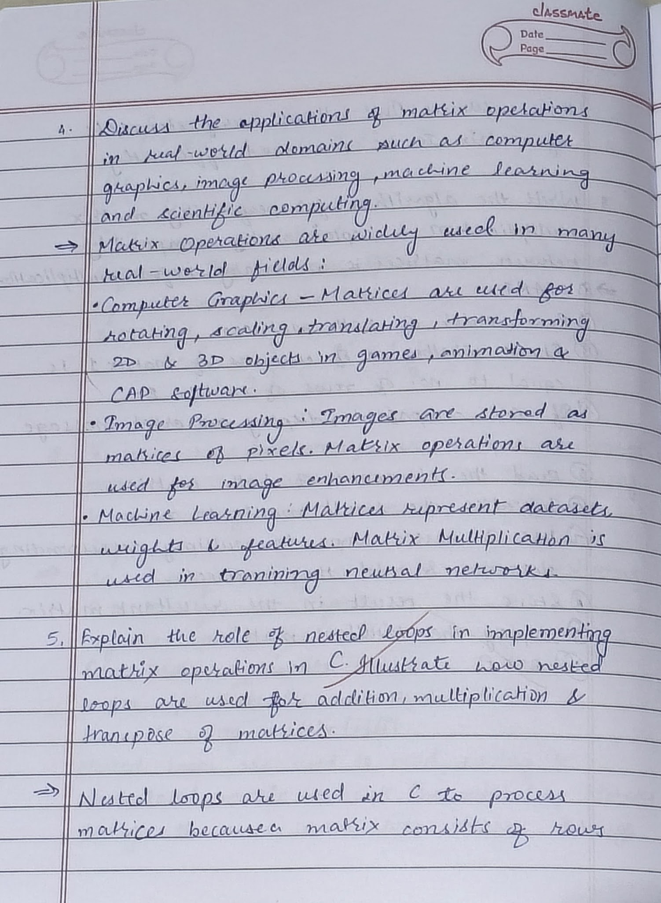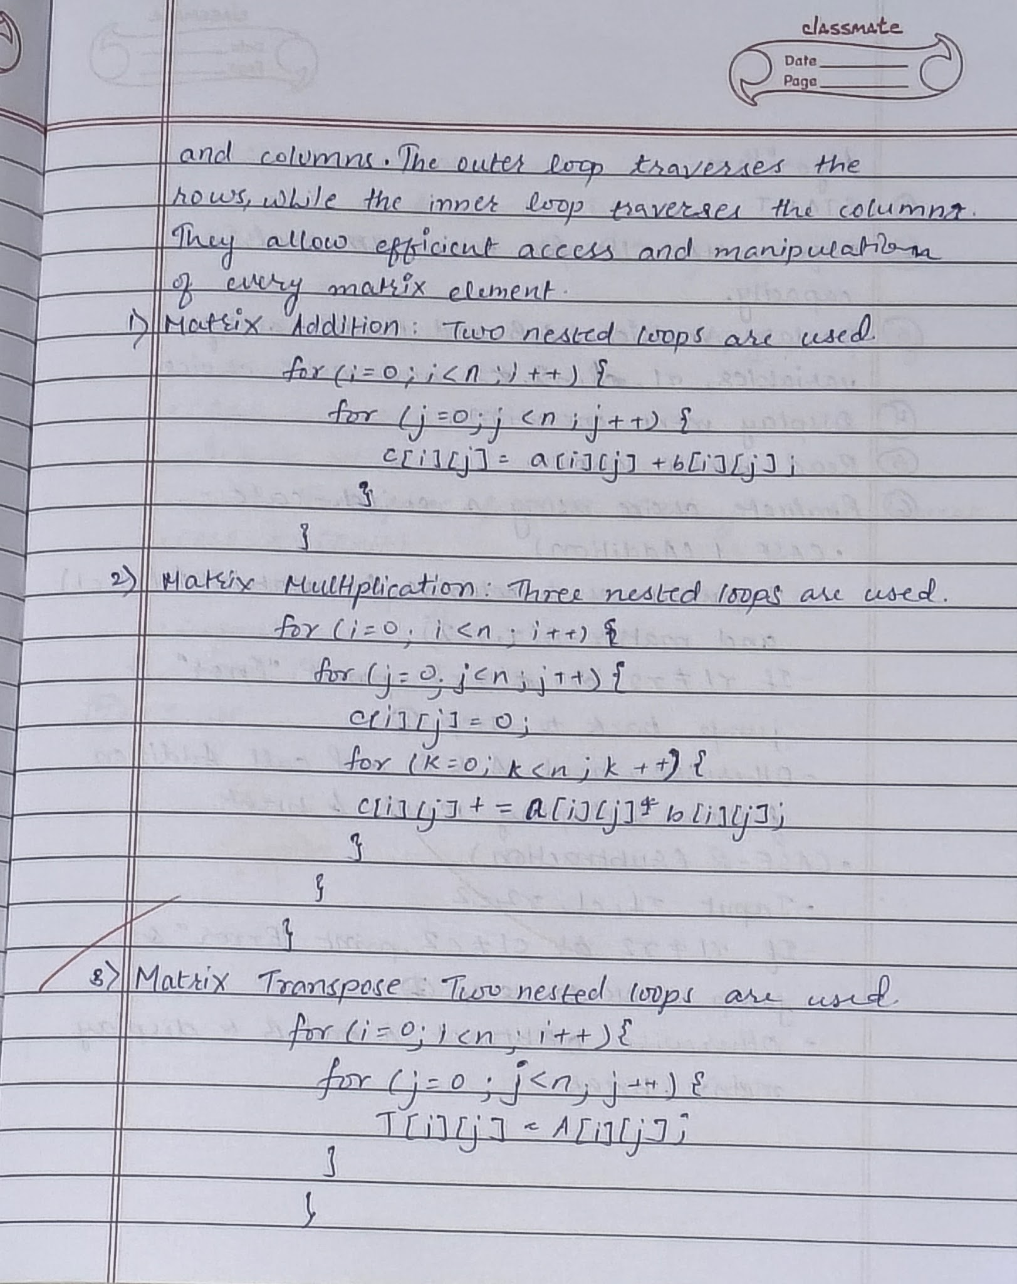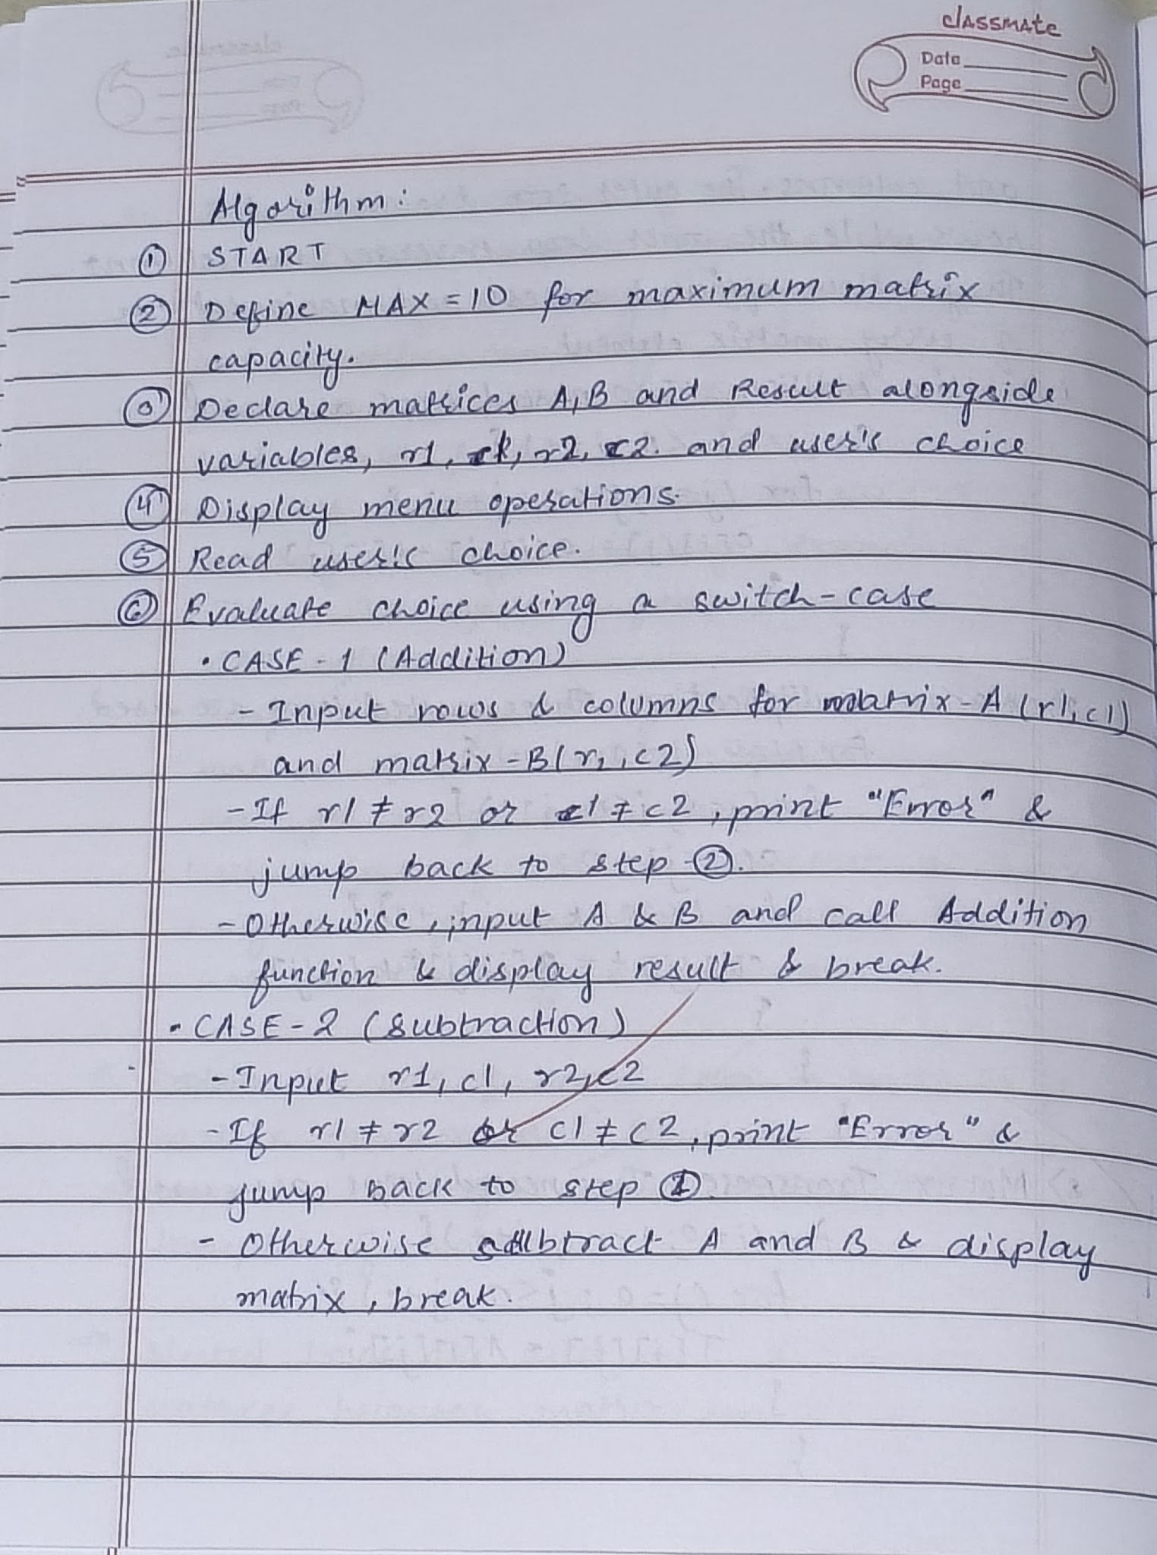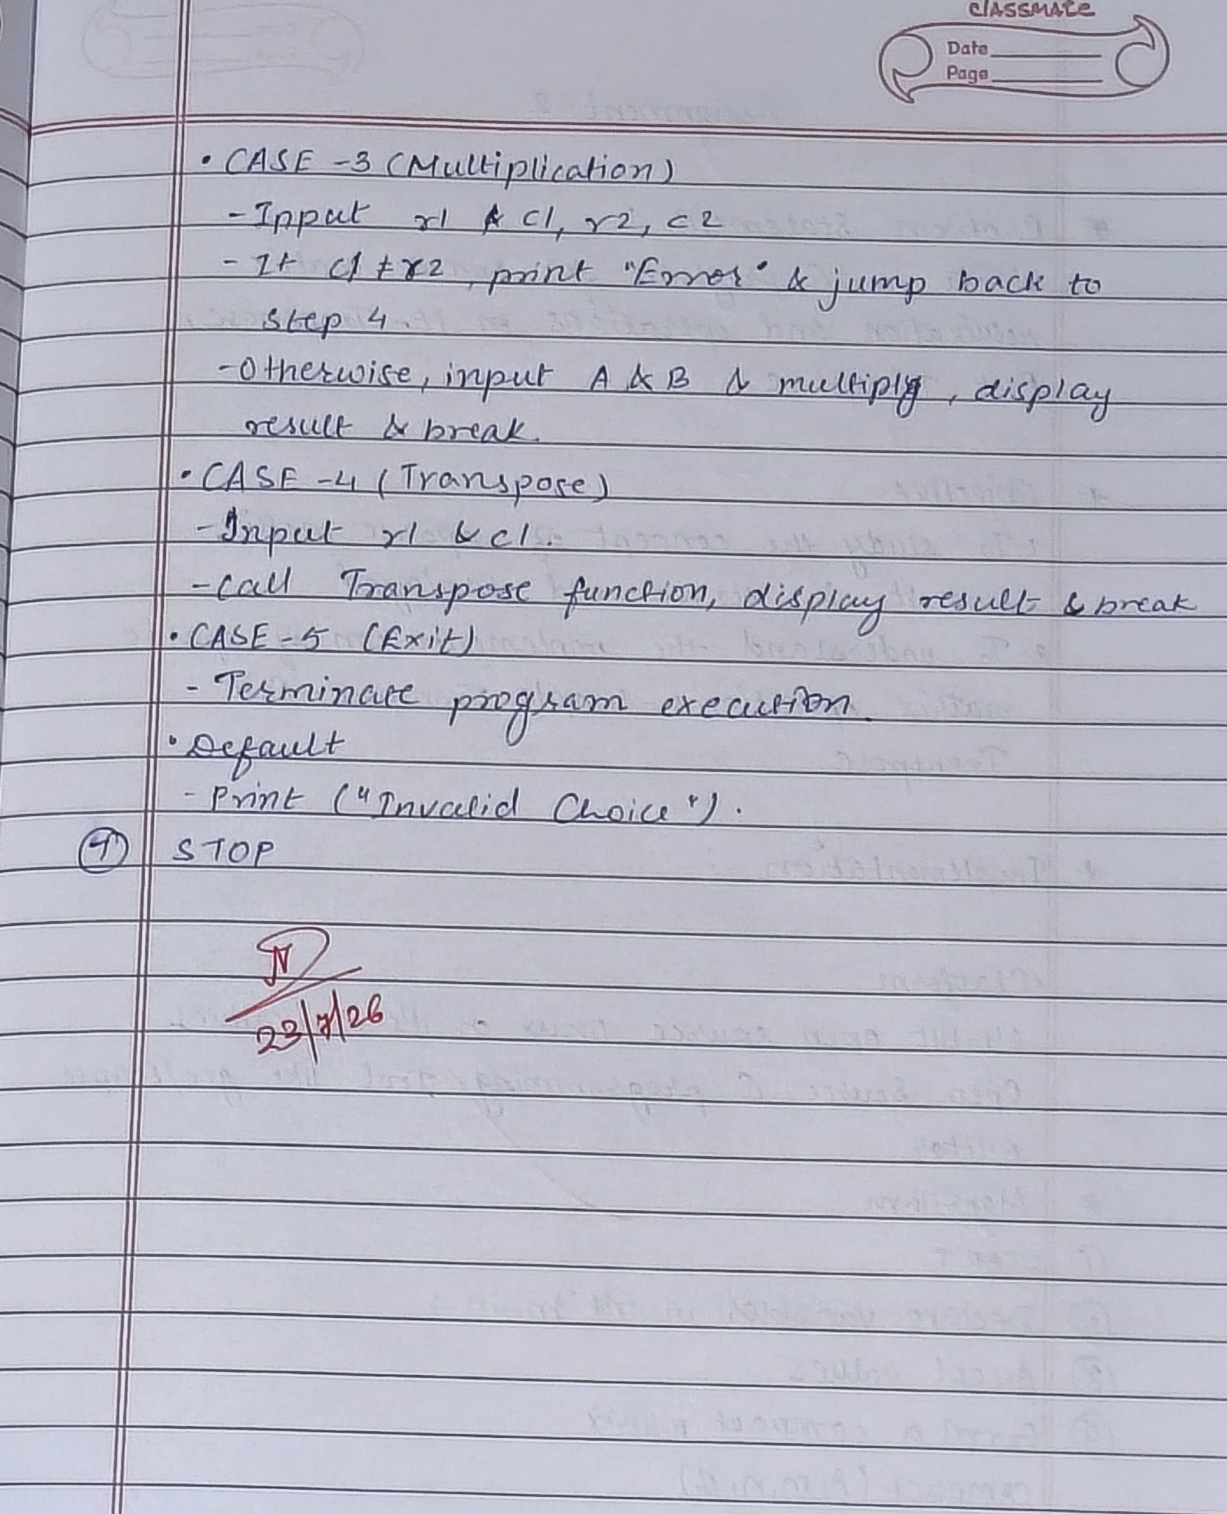

CODE :
#include <stdio.h>
#include <stdlib.h>

void accept(int a[10][10], int m, int n)
{
int i, j;

printf("\nEnter the elements of the matrix:\n");
for(i = 0; i < m; i++)
{
for(j = 0; j < n; j++)
{
scanf("%d", &a[i][j]);
}
}
}

void display(int a[10][10], int m, int n)
{
int i, j;

printf("\nMatrix:\n");
for(i = 0; i < m; i++)
{
for(j = 0; j < n; j++)
{
printf("%d\t", a[i][j]);
}
printf("\n");
}
}

void add(int a[10][10], int b[10][10], int m, int n)
{
int c[10][10], i, j;

for(i = 0; i < m; i++)
{
for(j = 0; j < n; j++)
{
c[i][j] = a[i][j] + b[i][j];
}
}

printf("\nAddition of matrices:\n");
display(c, m, n);
}

void subtract(int a[10][10], int b[10][10], int m, int n)
{
int c[10][10], i, j;

for(i = 0; i < m; i++)
{
for(j = 0; j < n; j++)
{
c[i][j] = a[i][j] - b[i][j];
}
}

printf("\nSubtraction of matrices:\n");
display(c, m, n);
}

void multiply(int a[10][10], int b[10][10], int m, int n)
{
int c[10][10], i, j;

for(i = 0; i < m; i++)
{
for(j = 0; j < n; j++)
{
c[i][j] = a[i][j] * b[i][j];
}
}

printf("\nElement-wise Multiplication:\n");
display(c, m, n);
}

void divide(int a[10][10], int b[10][10], int m, int n)
{
int c[10][10], i, j;

for(i = 0; i < m; i++)
{
for(j = 0; j < n; j++)
{
if(b[i][j] == 0)
{
printf("\nDivision by zero is not possible.\n");
return;
}

c[i][j] = a[i][j] / b[i][j];
}
}

printf("\nDivision of matrices:\n");
display(c, m, n);
}

void transpose(int a[10][10], int m, int n)
{
int t[10][10], i, j;

for(i = 0; i < m; i++)
{
for(j = 0; j < n; j++)
{
t[j][i] = a[i][j];
}
}

printf("\nTranspose of Matrix A:\n");
display(t, n, m);
}

int main()
{
int a[10][10], b[10][10];
int m, n, ch;

printf("Enter number of rows and columns: ");
scanf("%d%d", &m, &n);

printf("\nEnter Matrix A:");
accept(a, m, n);

printf("\nEnter Matrix B:");
accept(b, m, n);

printf("\nMatrix A:");
display(a, m, n);

printf("\nMatrix B:");
display(b, m, n);

while(1)
{
printf("\n\n----- MENU -----");
printf("\n1. Addition");
printf("\n2. Subtraction");
printf("\n3. Multiplication");
printf("\n4. Division");
printf("\n5. Transpose");
printf("\n6. Exit");

printf("\nEnter your choice: ");
scanf("%d", &ch);

switch(ch)
{
case 1:
add(a, b, m, n);
break;

case 2:
subtract(a, b, m, n);
break;

case 3:
multiply(a, b, m, n);
break;

case 4:
divide(a, b, m, n);
break;

case 5:
transpose(a, m, n);
break;

case 6:
exit(0);

default:
printf("\nInvalid choice!");
}
}

return 0;
}

OUTPUT :
